Lab 6 Population Regulation and Harvesting

With Answers

## Looking for density-dependence in a time series

The graph below shows the number of robins breeding around Nashville MI from 1968 to 2019 from the Breeding Bird Survey (ref).

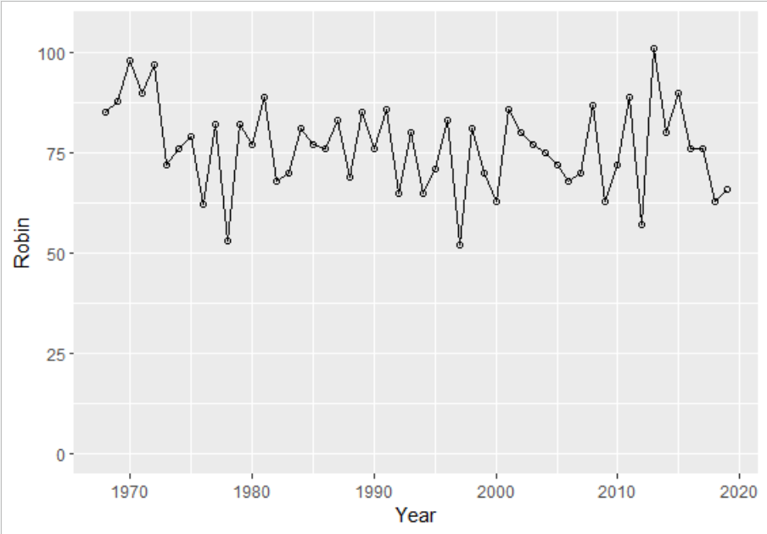

The numbers seem to fluctuate within a limited range of about 50 to 100. Is there some density dependence?

The data file is available on Canvas: 4BirdsNashvilleMI.csv . Download it and open it in R.

What would you do to look for density dependence? Think about the lecture and reading.

Q1.1 What is the mean population size of robins from 1968-2019?

To test the hypothesis that robin population size is regulated by density dependence, you will plot Nt/Nt+1 as a function of time (year), perform a linear regression, and find the equilibrium on the graph.

Q1.2 Which of the following options best describes the equilibrium value you must identify?

* slope of the regression line
* y-intercept of the regression line
* population size at which the estimated value of Nt+1/Nt = 1.
* population size at which we see the maximum estimated value of Nt+1/Nt.

Q1.3. Using the code provided in the file PopRegnLab2.R, use ggplot to create the graph described above. Include a regression line and indicate the position of the equilibrium point. Be sure that your names are in the plot title, save it as a gif, png, or pdf, and upload the image to Gradescope.

Q1.4 Does your analysis indicate that the robin population is regulated by density-dependent factors? Justify your answer with reference to the plot you uploaded and the mean population size you calculated for Q1.1.

Here are some tools you might use in R:

Keep a data frame as the main object attach(dataframe)

Average/ mean <- mean(VectorName)

New dataframe <- data.frame(vector1, vector2)

Shorten a vector by 1 element: <- vectorName[-length(vectorName)]

Make Nt/Nt+1 <- VectorName[-1]/VectorName[-length(VectorName)]

Regression to find slope and intercept through points x, y :

reg<-lm(formula = x ~ y, data=New.dataframe)

#get intercept and slope value

coeff<-coefficients(reg)

intercept<-coeff[1]

slope<- coeff[2]

Create basic ggplot (don’t forget require(ggplot) )

ggp <- ggplot(newdataframe, aes(x, y)) + geom_point()

and add the regression line (red dashed) to the basic ggplot called ggp

ggp + geom_abline(intercept = intercept, slope = slope, color="red",

linetype="dashed", size=1.5) +

ggtitle("My Title")

Add horizontal (h) or vertical (v) lines to a ggplot at particular locations

+ geom_hline(yintercept=5, linetype="dashed", color = "blue")

+ geom_vline(xintercept=100, linetype="dashed", color = "pink")

Put the above components together as needed to see whether there is density dependence.

Q 1.1 You will likely have created an informative plot. Be sure that your names are on it, and save it as a gif, png, or pdf and upload to Gradescope.

Answer: Code is on Box, called PopRegnLab2

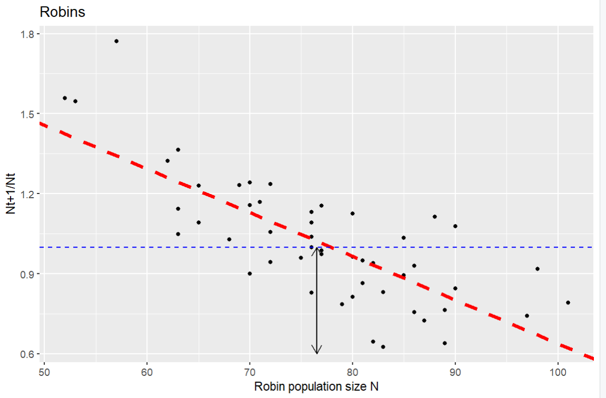

Q 1.2 Where on the graph is the equilibrium point? Upload an image showing this. You may draw your arrow on the graph using anything you like or try the ggplot segment command:

geom_segment(x = *beginx*, y = *beginy*, xend = *endx*, yend = *endy*, arrow = arrow(length = unit(0.03, "npc"), ends = "both"))

which will give a double headed arrow that starts at *(beginx, beginy)* and runs to *(endx, endy)* co-ordinates on the plot.

Answer: see above, the double headed arrow

Q 1.3 What is the value of the average population size of robins in this time interval? Enter a number to one decimal place.

Answer: 76.5

Q 1.4 Is the equilibrium point similar to the average population size?

Answer: it is close – I put the double-headed arrow at the average, which is a little below the intersection point.

Q 1.5 A pair of robins can build several nests per year in the forks of trees, but fledgling success is low. They eat mostly worms and insects, hunting on the ground, and berries of shrubs and trees when invertebrate prey become scarce. What factors might be behind the density-dependence of their growth?

Answer: There is not a lot of data specific to American robins! But nest site availability, territoriality,food supply, and predation on fledgings are likely density dependent factors. Accept reasonable responses that do not include density independent factors (harsh winters for example).

## Birth and Death rates

Time series data cannot tell us much about the particular factors regulating a population.

Recall the basic population growth equation:

ΔN=(b−d)⋅Nt Equation 1

b and d (that is, r), the per capita birth and death rates, were considered to be constant. Now we want them to be functions of abundance. In particular, as abundance goes up, b goes down (becomes less favorable):

b=bmax−a∗Nt Equation 2

For the death rate d we might expect it to go up as abundance goes up (becomes less favorable):

d=dmin+c∗Nt Equation 3

The above equations nicely illustrate the meaning of density dependence. That is, one or more vital rates are dependent on density! The constants *a* and *c* measure the strength of density dependence. b max and dmin are the maximum and minimum per capita birth rates and death rates.

Where will growth stabilize? When b=d, ΔN=(b−d)⋅Nt =0 so growth stops. That is at the intersection of the lines.

We can visualize this with the following code, found in the file pop.flow on Canvas.

# Define the Rates function

pop.flow = function(b,d,a,c) {

# Population size

N = seq(0,100,5)

# Define per-capita birth and death rates where b = b(max) and d=d(min)

pcbr = b - a*N

pcdr = d + c*N

# Plot per-capita birth and death rates as a function of N

plot(N,pcbr,type='l',col='blue',lwd=2,ylim=c(min(c(pcbr,pcdr)),max(c(pcbr,pcdr))),xlab='Population Size (N)',ylab='Rate')

lines(N,pcdr,col='red',lwd=2)

legend(0.5,max(c(pcbr,pcdr)),c('p-c birth rate','p-c death rate'),pch=15,col=c('blue','red'))

# Add flow information

text(1,(1-0.25)*min(c(pcbr,pcdr)),'Flow',cex=1.5)

for (i in 1:length(N)) {

loc = i

if (pcbr[loc] > pcdr[loc]) {

text(N[i],min(c(pcbr,pcdr)),'>',cex=1.5)

}

if (pcbr[loc] < pcdr[loc]) {

text(N[i],min(c(pcbr,pcdr)),'<',cex=1.5)

}

if (pcbr[loc] == pcdr[loc]) {

text(N[i],min(c(pcbr,pcdr)),'--',cex=1.5)

}

}

}

# Plug in parameter values and run

pop.flow(b = 0.8, d = 0.2, a = 0.01, c = 0.01)

You can change the values in the last line, pop.flow, and it will run all the statements above that as they are all part of the function.

Try running the code and changing the parameters a few times.

Q2.1 What are the arrows in the figure pointing towards?

Answer: the equilibrium point, where the birth rate = the death rate

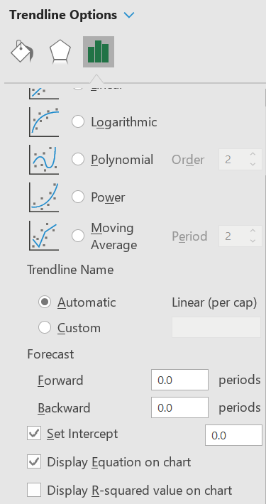Let’s use some real data in these equations. The Mandarte Island song sparrows have been well studied. Mandarte is a small uninhabited island between Vancouver Island and the mainland, and complete censuses of nests and survival rates of adults were taken for 15 years. You can find these in a file “Mandarte Sparrows” on Canvas. You will need to find the values of bmax, dmin, a and c by fitting equation 2 and equation 3 to these data. You can use R and the regression (lm) code under question 1, or you can fit a line in Excel or Sheets (make the graph, add a trend line, and show the equation). Note that if an intercept is negative, you will instead want to force the line through zero. To force the line through 0 in R:

birds.lm <- lm(x ~ y, data = birds)

birds.lm2 <- lm(x ~ 0 + y, data = birds) *# Adding the 0 term tells the lm() to fit the line through the origin*

In Excel, under the trendline options there is a checkbox to set the intercept. In Sheets, see the video [here for a workaround](https://www.google.com/search?q=google+sheets+trendline+through+0&rlz=1C1CHBF_enUS944US944&oq=google+sheets+trendline+through+0&aqs=chrome..69i57j0i22i30l2j0i390l4j69i64.9587j0j4&sourceid=chrome&ie=UTF-8#kpvalbx=_hF9xY537FOTA0PEP6ZiUyAk_27):

Q 2.2 What are the values you found for *bmax, dmin, a* and *c*?

Answers:

Bmax = 4.96 a = 0.0515

Dmin = 0 (forced) c = 0.0626

I got these by fitting lines to plots of BR and DR vs Nt in Excel, and adding the lines.

Q 2.3 Now use these values to generate a graph using pop.flow. Put your names on the graph (add title(main = "our names") and upload it to Gradescope.

Answer:

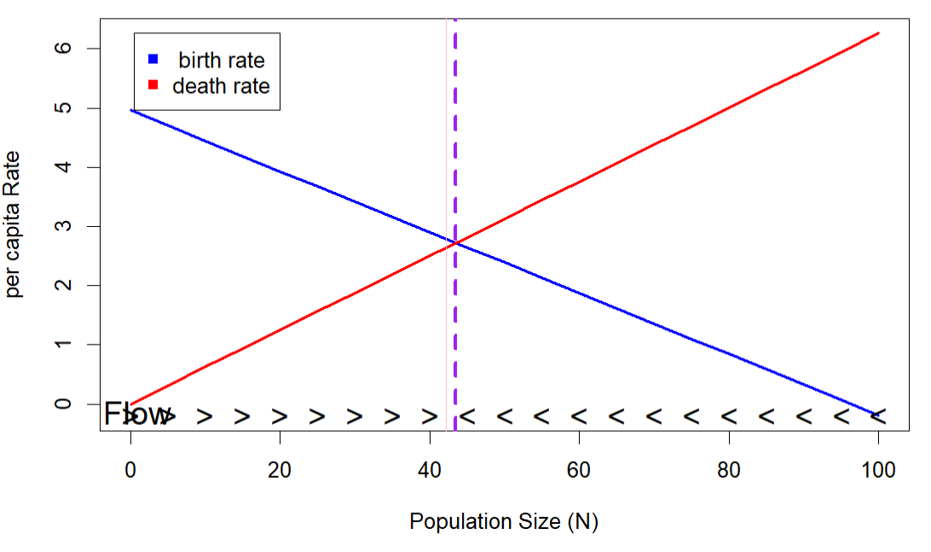

I added the lines at 42.2 and 43: 5 with abline(v=c(42.2,43.5), col=c("pink", "purple"), lty=c(1,2), lwd=c(1, 3))

Q 2.4 What is the equilibrium number of females expected on the island? How does this compare to the average number of females on the island?

Answer: equilibrium number (from graph) about 42

Average number (from excel file): 42.2

With a little algebra, (you can see it [here](https://jdyeakel.github.io/teaching/ecology/section9/)) it can be shown that the carrying capacity, K is equal to

Equation 4

Q. 2.5 Using your values for *bmax, dmin, a,* and *c* and equation 4, what is the carrying capacity? Enter a number to one decimal place.

Answer: = 4.96/ (0.515 + 0.0626) =43.47 ~= 43.5

What if the birth or death rates are not a linear function of the density? You can easily think of situations where that would be true: if it gets harder to find mates as the density decreases, or if animals cooperate to catch prey or spot predators, such that at intermediate densities they survive better than at lower densities. We can turn the linear functions of equation 1 and 2 into polynomials.

b=bmax−a∗Nt à bmax−a∗Nt – f * Nt2

d=dmin+c∗Nt à dmin+c∗Nt – g * Nt2

For the Mandarte sparrows, the equations we fit are:

b = 4.63 – 0.026 Nt - 0.0003 Nt2

d = 0.56 – 0.048 Nt + 0.0018 Nt2

Q 2.7 Modify the code of pop.flow above to plot the graph with the polynomial lines instead of the linear relationship. (Hint: lines 8-10 are where you should be looking & since you will only do this for the one situation, you don’t need to make new variables for the function.) Upload the graph to answer this question, with your names in the title.

Answer: by “not making new variables”, I mean they can just add - 0.0003 Nt2 and + 0.0018 Nt2 to lines 9 & 10

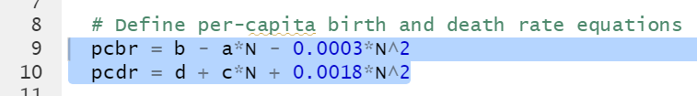

Answer: 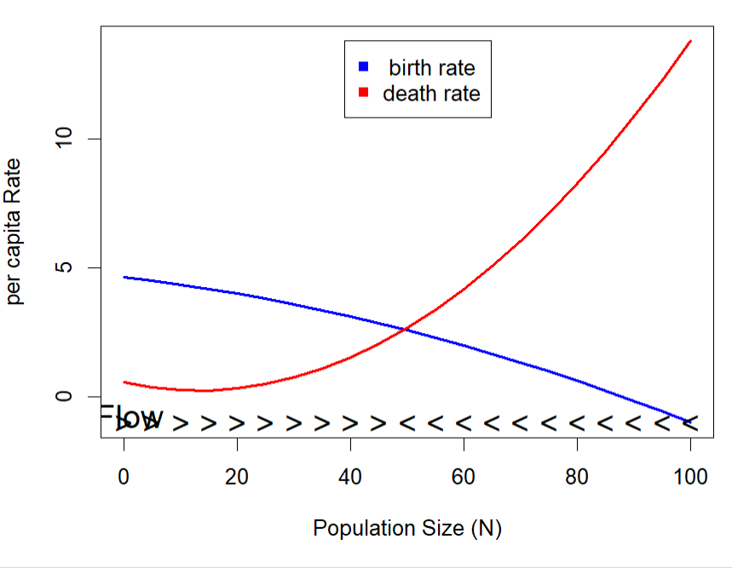

Q 2.6 Consider these per capita death and birth rate curves:

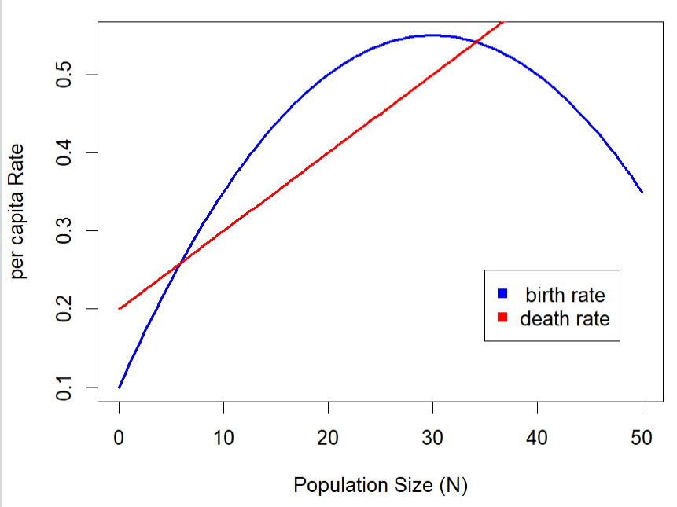

Add flow arrows to indicate whether the population size would increase or decrease at each population size. Indicate the equilibrium population size(s). Upload your marked-up graph as a gif, png or pdf.

Answer: (2 equilibria, one stable one unstable), I added vertical lines

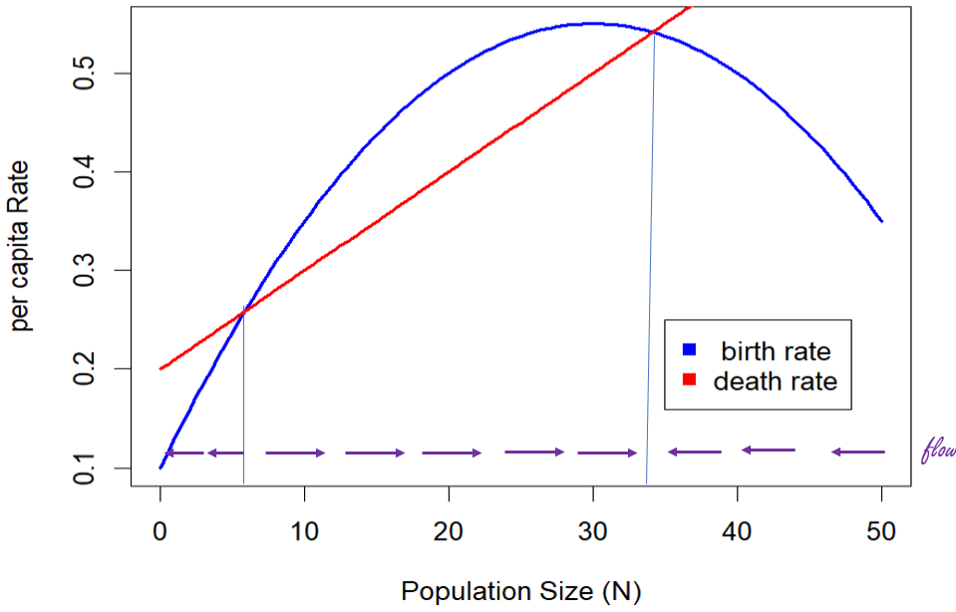

## Harvesting

Organisms are renewable resources, and humans would like to harvest individuals of some species, while maintaining viable populations. If species grow back in a logistic manner, we should be able to reduce their numbers to the point where the higher growth rate at lower densities will allow for a rapid recovery. We have not been very successful at this, particularly for fish populations with open access.

To see how we might manage a logistically growing population we are going to plot the growth increment (recruitment, number of individuals added to the population, delta N) versus the population size.

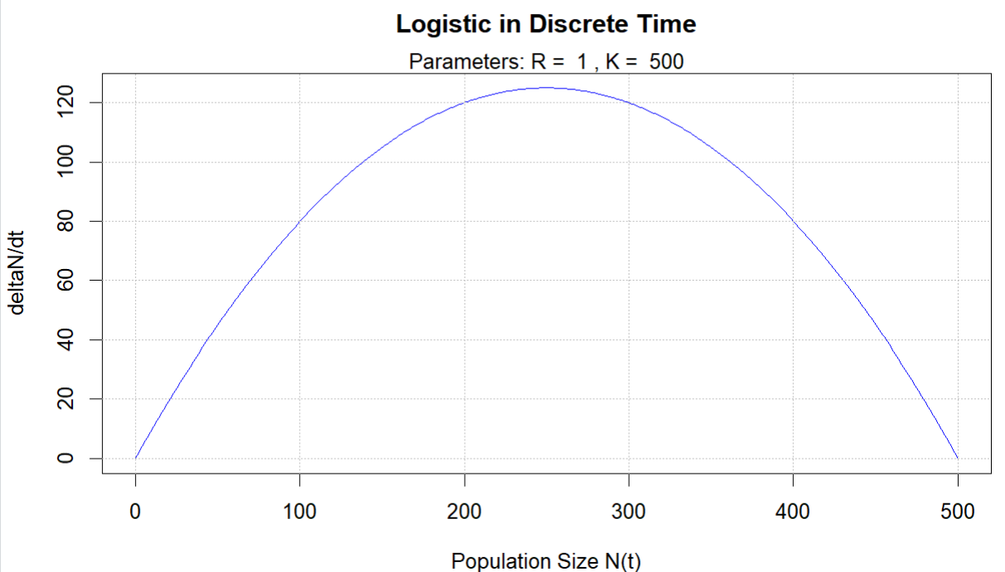

Q. 3.1 If we start at the carrying capacity, and harvest 100 individuals, what will the new population size be? (you can read this off the graph).

Answer: 400 (the carrying capacity is 500)

Q. 3.2 How many individuals would be added to the population over the next year (read from the blue line) ______ and what then will be the final population size? ______

Answers: 80 (blue line at 400) and 480.

Q 3.3 Now repeat the harvest of another 100 individuals, and the recovery afterwards, and repeat again until it stabilizes. Mark on the graph the population size after each round (number each). Upload the graph.

Answer:

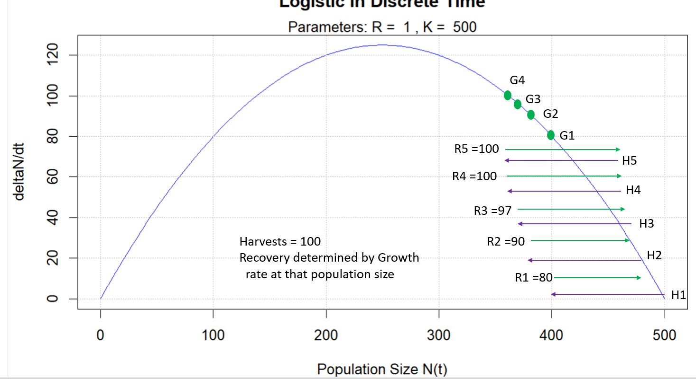

Q 3.4 If you start at 200 and harvest 100 each year, what happens?

Answer:

( ) The population stabilizes at about 130

( ) The population stabilizes at 500

(X) The population goes extinct because the growth rates are not fast enough at this high rate of harvest

( ) The population goes extinct in 2 years

* If the harvest was done less frequently, the population would have the time to grow and could recover from the harvest

Q. 3.5 Managers often set a constant harvest rate for a population in an area (e.g a certain number of hunting or fishing licenses, a certain quota of fish caught). The graphs below show a c**onstant** harvest rate, first of zero, then a rate of 40 per year. (The line for 40 is drawn in on the first plot for comparison. Copy the second plot and add flow arrows and label any equilibrium points as stable or unstable. Upload to answer the question.

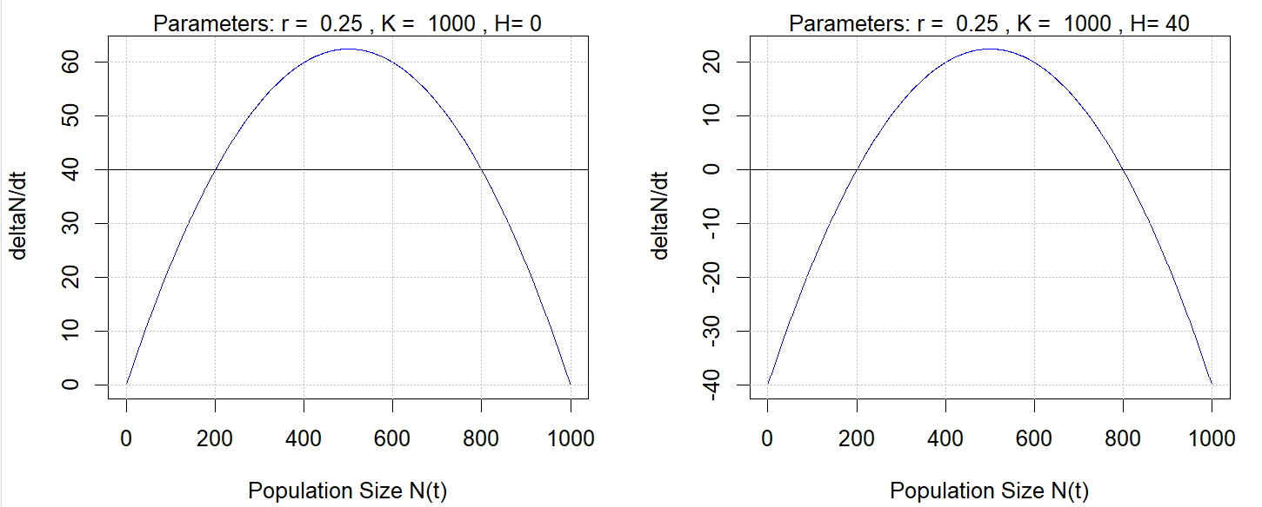

Answer:

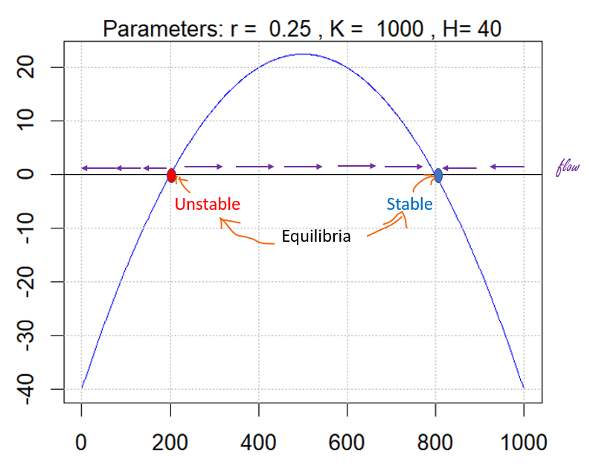

Q. 3.6 If there are few animals, we would probably want to decrease the harvest rate, and if there are many we might increase it. The graphs below make the harvest rate a function of population size. The graph at left is the same unharvested population, with a line added indicating the harvest rate. Again, copy the second graph, add flow arrows. And upload it to answer this question.



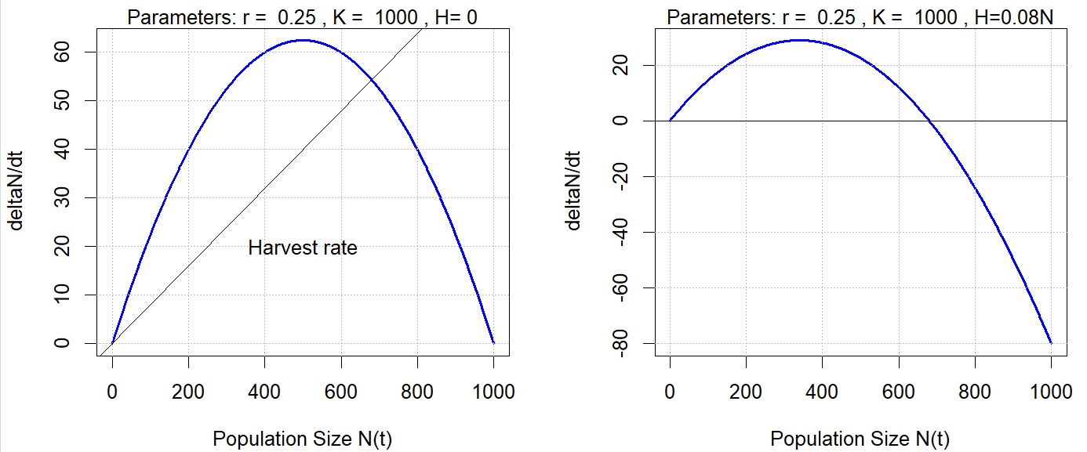



Answer:

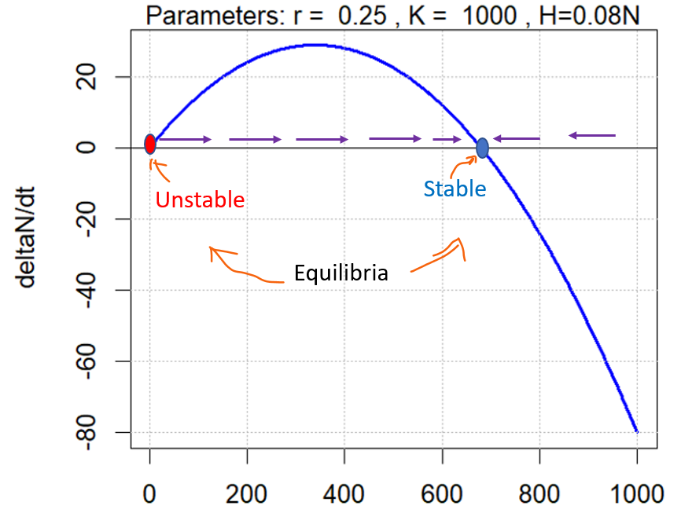

Q 3.7 Summarize the difference in behaviour of the population in response to the two approaches to harvesting.

Answer (maybe make MC? ) the lower, unstable equilibrium has been eliminated when harvesting adjusts to population size so the population should be more resilient. There is a narrower range of population sizes for which there is positive growth